**URDF Wheel**

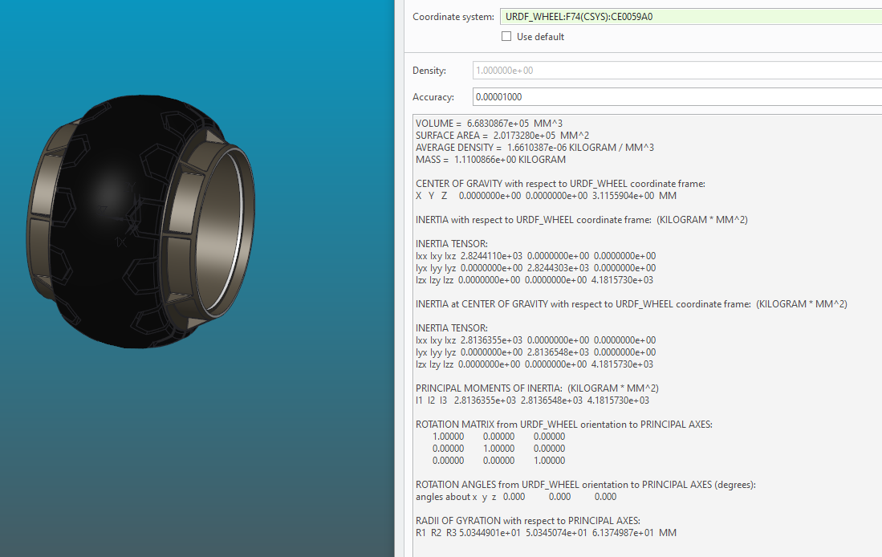

VOLUME = 6.6830867e+05 MM^3

SURFACE AREA = 2.0173280e+05 MM^2

AVERAGE DENSITY = 1.6610387e-06 KILOGRAM / MM^3

MASS = 1.1100866e+00 KILOGRAM

CENTER OF GRAVITY with respect to URDF_WHEEL coordinate frame:

X Y Z 0.0000000e+00 0.0000000e+00 3.1155904e+00 MM

INERTIA with respect to URDF_WHEEL coordinate frame: (KILOGRAM * MM^2)

INERTIA TENSOR:

Ixx Ixy Ixz 2.8244110e+03 0.0000000e+00 0.0000000e+00

Iyx Iyy Iyz 0.0000000e+00 2.8244303e+03 0.0000000e+00

Izx Izy Izz 0.0000000e+00 0.0000000e+00 4.1815730e+03

INERTIA at CENTER OF GRAVITY with respect to URDF_WHEEL coordinate frame: (KILOGRAM * MM^2)

INERTIA TENSOR:

Ixx Ixy Ixz 2.8136355e+03 0.0000000e+00 0.0000000e+00

Iyx Iyy Iyz 0.0000000e+00 2.8136548e+03 0.0000000e+00

Izx Izy Izz 0.0000000e+00 0.0000000e+00 4.1815730e+03

PRINCIPAL MOMENTS OF INERTIA: (KILOGRAM * MM^2)

I1 I2 I3 2.8136355e+03 2.8136548e+03 4.1815730e+03

ROTATION MATRIX from URDF_WHEEL orientation to PRINCIPAL AXES:

1.00000 0.00000 0.00000

0.00000 1.00000 0.00000

0.00000 0.00000 1.00000

ROTATION ANGLES from URDF_WHEEL orientation to PRINCIPAL AXES (degrees):

angles about x y z 0.000 0.000 0.000

RADII OF GYRATION with respect to PRINCIPAL AXES:

R1 R2 R3 5.0344901e+01 5.0345074e+01 6.1374987e+01 MM

**T matrix Ankle yaw – wheel**

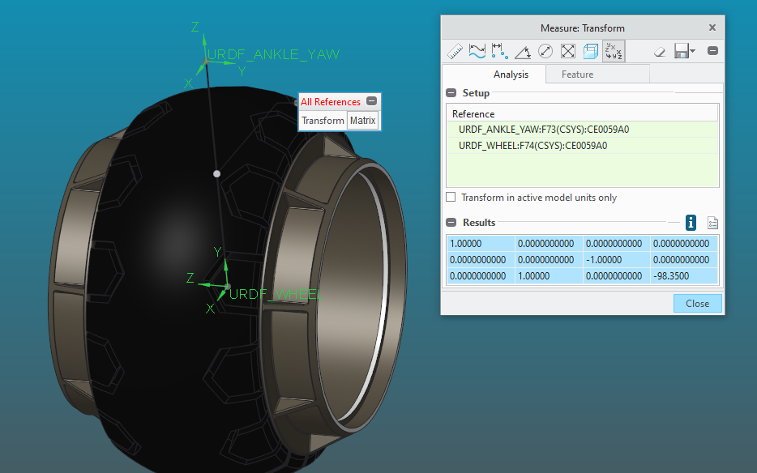

1.00000 0.0000000000 0.0000000000 0.0000000000

0.0000000000 0.0000000000 -1.00000 0.0000000000

0.0000000000 1.00000 0.0000000000 -98.3500